Customer Retention Case Study

> Our dataset has 269 rows and 71 columns.

> This dataset is the collection of the questionnaire which were asked in survey of Online retailers in Indian Market.

> **All the columns of the dataset are: -**

* 'Gender'
* 'Age'
* 'Shopping city',
* 'Pin_code_City',
* 'Shopping_Exp_Online',
* 'No_of_purchase_lastyear',
* 'Internet_Type',
* 'Device_shopping',
* 'Screensize_Mobile',
* 'Operating_system',
* 'Browser',
* 'Mode_of_conn_online_store ',
* 'Mode _of_conn_again',
* 'Time_duration_purchase',
* 'Payment_mode',
* 'Frequency_abandoning_items',
* 'Abandoned_bag_reasons',
* 'content_of_website_easy_toread_understand',
* 'similar_product_comparision_imp',
* 'Complete_info_listed_seller_product_imp_for_purchase_decision',
* 'All_relevant_information_on_listed_products_must_be_stated_clearly'
* 'Ease of navigation in website',
* 'loading_processing_speed',
* 'userfriendly_interface_website',
* 'Convenient_pay_methods',
* 'Trust_online_store_fulfill_itspart_oftransaction_intime',
* 'Readiness_to_help_customers',
* 'Guarantee_privacy_of_customers',
* 'Customer_support_availability_by_modes',
* 'Monetary_benefits_online_shopping_discounts',
* 'Enjoyment_from_online_shopping',
* 'Onlineshopping_convenient_flexible',
* 'Importance_return_policy_replacement_policy',
* 'Loyality_program_benefit_shopping_online',
* 'Quality_info_website_improves_satisfaction',
* 'Satisfaction_shopping_goodquality_website',
* 'benefit_derived_from_shopping_online_lead_users_satisfaction',
* 'User_satisfaction_with_trust',
* 'Wide_variety_product_category',
* 'Complete_and_relevant_product_info',
* 'Monetary_savings',
* 'Convenience_of_patronizing_online_retailer',
* 'Sense_of_adventure',
* 'Social_status_enhancement_by_shopping_retailer',
* 'Gratification_feeling_favourite_retailer',
* 'Shopping_website_helps_you_fulfill_certainroles',
* 'Value_for_money',
* 'online_retailer_shopped_from',
* 'Easy_to_use_website_application',
* 'Visual_appealing_webpage',
* 'Wild_variety_product_offer',
* 'Complete_relevant_description_about_product',
* 'Fast loading_website_application',
* 'Reliability_of_website_application',
* 'Quickness_shopping',
* 'Availability_of_payment_options',
* 'Speedy_order_delivery',
* 'Privacy_of_customers',
* 'Security_of_customer_fin_info',
* 'Perceived_trustworthiness',
* 'Presence_onlin_assist_multichannel',
* 'Longer_time_to_get_logged_in',
* 'Long_tim_displ_graphics_photos',
* 'Late_decl_of_price',
* 'Longer_pag_load_tim',
* 'Constraint_on_mostproducts_payment',
* 'Long_del_period',
* 'Website_&_application_change',
* 'Frequent_disruption_pageschanging',
* 'Efficient_website',
* 'Online_retailer_reccom'.

**We will take our few of columns for the analysis.**

* **Age**

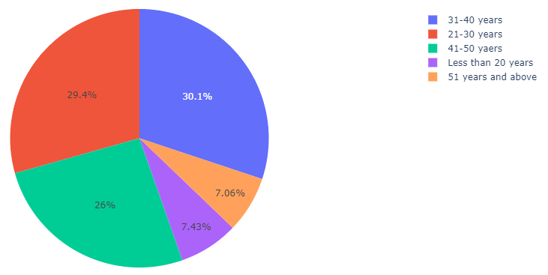

From the plots we can clearly see that most of the respondents fall into the following three categories: -

1. 31-40 years

2. 21-30 years

3. 41-50 years

Very few respondents fall into the categories: -

1. Less than 20 years

2. 51 years and above

* **Different browser used by the people for online shopping.**

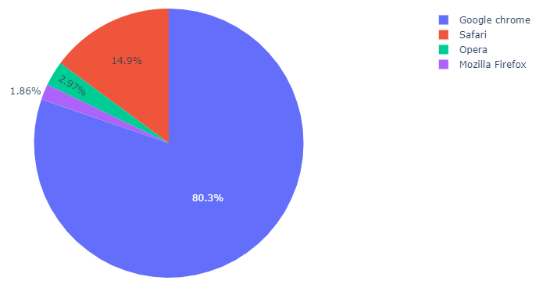

We can see that mostly people use "Google chrome" followed by "Safari".

Very less people use "Mozilla Firefox" & "Opera".

* **Fastest loading and Responsive website.**

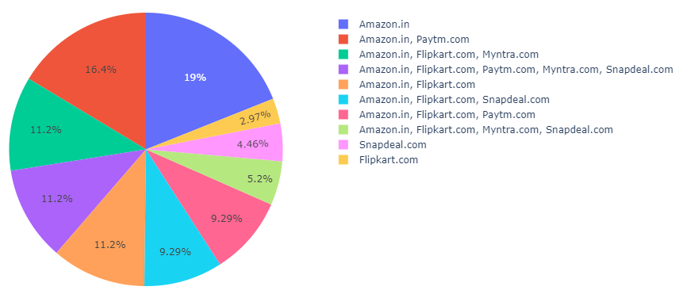

Our fastest loading and responsive website are in following order.

1. Amazon, 2. Paytm, 3. Myntra ,4. Flipkart.

* **Device used for the Shopping.**

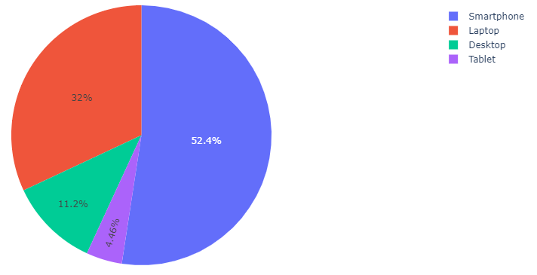

We can see that most people use Smartphone followed by the laptop for the online shopping.

* **GENDER**

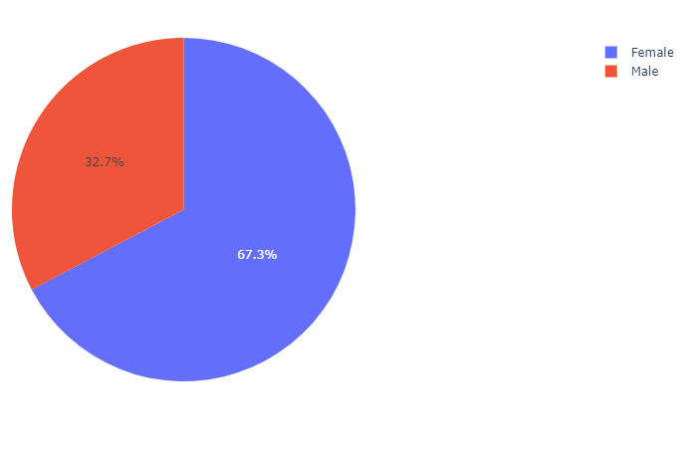

We can see that out of all respondents most people are from female gender.

* **PAYMENT METHOD FOR ONLINE SHOPPING**

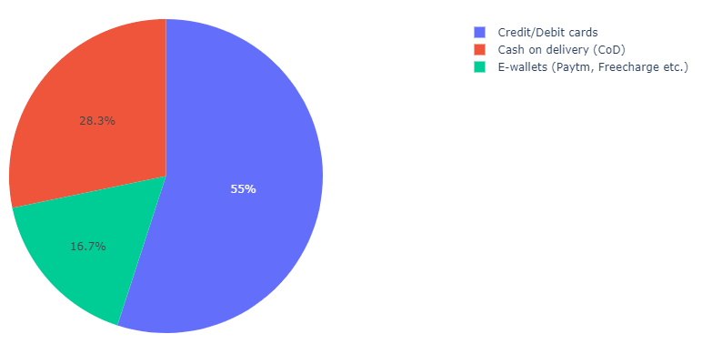

We can see that most of people use Credit card /Debit Cards for the payment.

Very few people go for the E-wallet payment method.

* **City**

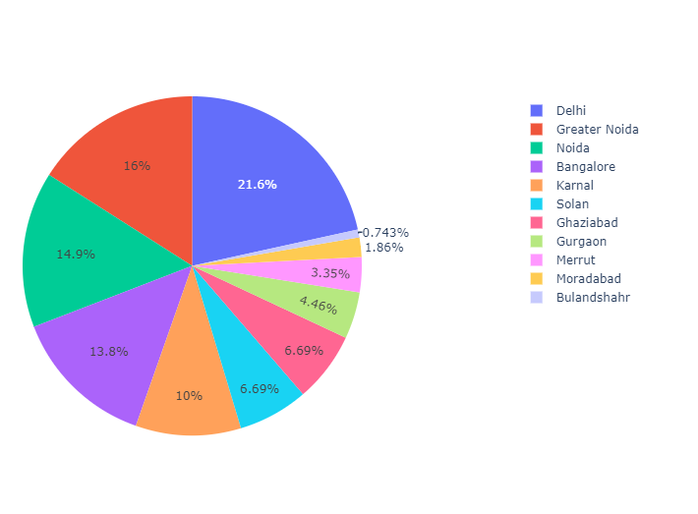

We can clearly see that most people reside in Delhi who have shopped online followed by Greater Noida, Noida and Bangalore.

* **Best Online shopping Platform for Recommendation to Others**

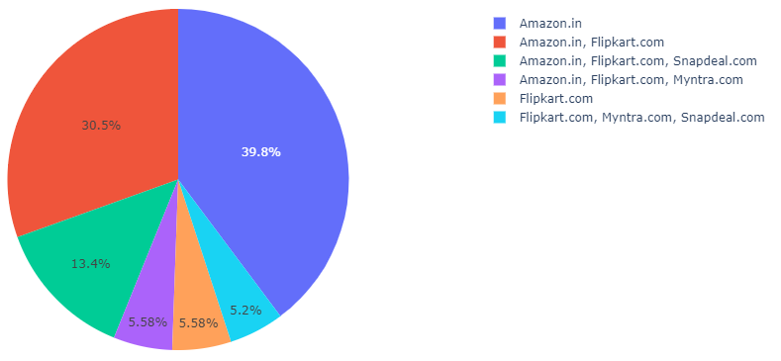

Amazon is the most recommended website followed by the Flipkart.

* **Internet Source for the Online Shopping**.

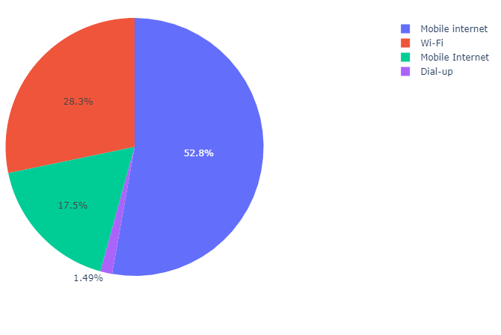

Most people rely on mobile internet for the online shopping followed by the Wi-Fi.

**Insights/Conclusion/Inferences**

* Amazon.in is the people’s favorite choice for the online shopping, since it is offering the sales of its products with various additional benefits like “Fastest delivering orders", "Fastest loading and responsive website", "More products are available for any section of item” etc.
* Flipkart is also performing good but it comes after the Amazon.
* Least rated online retailer companies are Snapdeal.com and Paytm.com, very less proportion of the population are following them due to the various reasons like “Very long delivery periods", "Slow loading website", "Less varieties of the products are listed on them” etc.